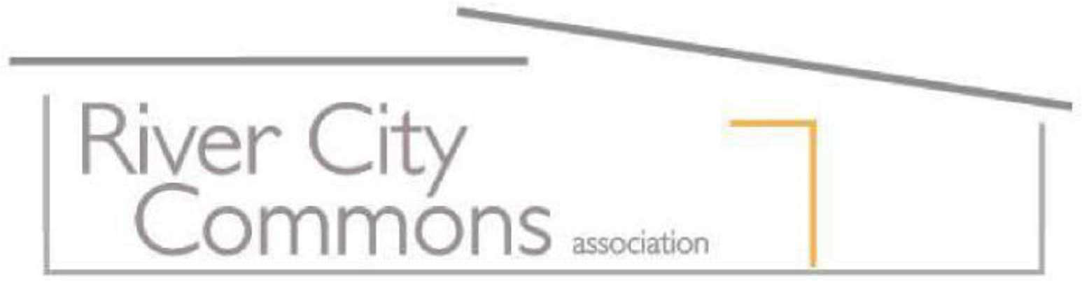
HOME IMPROVEMENT APPLICATION

Important: To comply with our CC&Rs, exterior changes to your property must be approved by the Association before starting work. Board decisions will be sent to you within 45 days after receipt of your application. Please plan your project schedule with this in mind.

General Conditions of Approval
- Improvements shall comply with RCC CC&Rs.
- Improvements shall comply with RCC Rules and Regulations, including the Architectural Guidelines approved by the Board of Directors.
- Construction shall comply with applicable laws, ordinances, codes and regulations within the County and City of Sacramento. Owners shall obtain all necessary approvals and permits.
- Construction waste or excavation material shall be disposed of properly.
- The Board has the option to contact surrounding neighbors regarding this project.
- A copy of the Architectural Guidelines can be obtained at: www.RiverCityCommons.com
- Upon receipt of approval, the work must begin within 90 days and take no more than one (1) year to complete.
Homeowner Name(s): ___________________________________________________________
Date of Application: _____________________________________________________________
ARC design required by: __________________________________________________________
Address: ______________________________________________________________________
Phone: _________________________ Email: _________________________________________
Approximate length of project (in months): __________________________________________

Please check the appropriate items that apply and provide details below.

Body of House

- Front doors
- Garage doors
- House lights
- House numbers
- Front windows
- Window borders
- Additional rooms
- Exterior walls (siding or stucco)
- Gutters
- Downspouts
- Solar panels
- Beams
- Other embellishments
Paint Color
- On any part of the house, fences, gates (whether current existing or different color)
Roof Area
- Roof fascia
- Room overhang
Service Equipment
- Satellite dishes
- Cable boxes
Landscape Changes (Hardscapes):

- Concreted area (drives, walks, mow, strips)
- Walkways and paths
- Retaining walls
- Rocks
- Gravel
- Patios
- Gazebos
- Fountains
- Decorative items (statues and plaques)
- Structures/equipment projecting over fence
- Patio covers
- Structures
- Furniture (i.e., benches)
- Fences
- Gates
- Fenced courtyard, or side-yard
- Pergolas
- Trellises
- Mulch
- Pots
- Arbors
- Irrigation systems
- Pools
- Spas

Landscape Changes (Softscapes visible from street):

- Trees
- Grass
- Vines
- Groundcover
- Shrubs
- Other living vegetation

Detailed Description of Project:
Please describe your project in clear detail for reviewers to fully understand it. Include colors, sizes/dimensions, sample colors and images, photos, scale drawings, and anything further that clearly illustrates the project. If additional space is needed, please attached extra page of this form (pg. 6)
__________________________________________________________________________________________________________________________________________________________________________________________________________________________________________________________________________________________________________________________________________________________________________________________________________________________________________________________
________________________________________________________________________________________________________________________________________________________________________________________________________________________________________________________________________________________________________________________________________________________________________________________________________________________________________________________________________________________________________________________________________________________________________________________________________________________________________________________________________________________________________________________________________________________

I hereby request authorization to make the above-listed improvements to my residence, which is located at the addresses indicated above. I understand and agree the River City Commons Architectural Rules currently in effect.

Applicant Signature: _________________________________ Date: ______________________

Submit your Home Improvement Application and supporting materials to:

EMAIL: custserv@omnicommunities.com

OR

MAIL:
River City Commons Association
c/o OMNI Community Management
Attn: Architectural Review
9807 Fair Oaks Blvd.
Fair Oaks, CA 95628

Direct Line: (196) 965-8964

Association Use Only:

RIVER CITY COMMONS ARCHITECTURAL REVIEW COMMITTEE

- Approved

- Denied

Comments:

Signed by: _________________________________ Date: ______________________________

Once the approved work is complete, please fill out the attached Certificate of Completion Form and submit to OMNI.

FINAL INSPECTION REPORT

Date Inspected: _______________________

Inspected by (signature): _________________________________________________________

Approved:
- Yes

- No

Comments:
______________________________________________________________________________________________________________________________________________________________________________________________________________________________________________________________________________________________________________________________________________________________________________________________________

(Submit this page separately upon completion of work)

Continued, Detailed Description of Project:

